
“Life at Mars Rod and Gun Club”
The Official Newsletter of Mars Rod and Gun Club, Inc. Website https://marsrodandgunclub.org
Email: marsrodandgunclub@gmail.com
Facebook: Mars Rod and Gun Club Official Page (Need member #) May 2026
No shooting on Sundays before 12 PM
Trap Practice every Tuesday 5PM – 8PM.
5/19/26 Tuesday ELECTION DAY-Please get out and vote!
5/25/26 Monday - Memorial Day – Taps Across America 3PM sharp!!!!! Main St, Evans City at Memorial
5/28/26 Thursday New Member Orientation 7pm
5/30/26 Saturday Bill’s Pistol Shoot Set up 8am; 9:45- Mandatory Safety Brief ; 10AM-Shooting Starts , Ranges closed Dawn to 4 PM
6/1/26 Monday - North Suburban Traveling Trap League @ Mars – shooting starts at 4 PM Ranges closed at 3PM
6/3/26 Wednesday Butler County Trap League 4PM-7:30 PM Ranges close at 3 PM
6/4/26 Thursday Monthly Membership Mtg 7PM
6/6/26 Club Rental - Ranges closed 11 AM to Dark
6/7/26 Sunday 22 LR Precision Shoot- Set Up 11:00, Registration 1130, Mandatory Safety brief 1145, Shooting 12 PM Ranges close 10AM
6/7/26 Club participating in Butler Co. WingFest—come support the Club and vote for our wings
6/18/26 Thursday Officers & BOD mtg 7:00 PM
6/20/26 Saturday - Rental – Grounds and ranges closed at 11am till Dark
6/25/2026 6/29/26 Thursday New Member Orientation 7PM,
6/27/26 250th Anniversary and Pig Roast 4PM doors open/5:00 Dinner RSVP to Faye Ranges closed at 3 PM
6/29/26 Monday - North Suburban Traveling Trap League @ Mars – shooting starts at 4 PM Ranges closed at 3PM
Save the Date: 7/18/26 Saturday Women on Target Ranges closed Dawn to 5P

**Don’t forget to Vote on Tuesday, May 19th. FOAC recommendations attached to email.

Membership Update: The following person attended a NMO in April & their name read at May meeting. This is Josh Vogel (R). He will need to be present at the June mtg to be voted on.
The following individuals attended a NMO session, their names read at a meeting and published in a newsletter. They were voted onto membership at the April meeting, Marc (R), Patrick (A) and Jonnie (J) Maestra. Welcome to the Club!
Not sure who some of the new faces are? Take a moment to introduce yourself and offer a handshake to help them feel welcome. A simple greeting can make a big difference—ask if they have any questions about the meeting or event and help them get connected and comfortable.
If you—or someone you know—are interested in membership, we’re here to help! Feel free to reach out to Faye directly or use the “Contact Me” form on our website for more information. Our next New Member Orientation will be held on Thursday, May 28, 2026 at 7:00 PM and the next meeting is June 25, 2026 at 7:00 PM.



Come celebrate 250th Anniversary of the USA with a Pig Roast on Saturday, June 27, 2026 at the Club! We are getting a pig to roast and have Tom B willing to roast it. We would ask everyone to bring a dish and will be a suggested donation of $5 with children 12 & under free. Doors open 4 PM, Dinner at 5:00 PM and fireworks at dark too! Kraig Wolf accepting donations to offset cost of boom booms! More details will follow. RSVP to Faye 724-321-2691 or sign up on sheet at Club!

Women on Target Saturday, July 18, 2026! Talk to the women in your life and their friends and family about this event. Sign up sheets are available for registration. Need volunteers to sign up to help with set-up/clean-up/delivering water, etc. or with being a buddy for each woman participating in this event. One does not have to be a RSO, but be familiar with guns and safety. Any questions, call Julie McClelland @ 412-443-6972. Sign up sheet at Club.


Bill’s Pistol Shoot Saturday May 30, 2026. Come see what those having fun looks like! Set up starts at 8am/clean up immediately after - one can get activity hours for this. Registration starts at 9:00 am, Mandatory Safety Meeting at 9:45 AM, Shooting from 10:00 AM to 2:00 PM, Hearing and eye protection mandatory, Bring your gun(s) and ammo. $10.00 to participate (children shoot free), Donation for Lunch. Call Bill Caudill for information 724-755-1876. Who can hit the Texas Star?
Butler County Wingfest at The Beacon Sun June 7, 2026. The Club is participating again this year so come and support us!!! VIP with tickets - doors open at 12:30 PM (get in line for wings early) and if buy at door 1:00. Serving wings at 1:00 so get in line. Each vendor will give you 3 wings (but you can go back as many times as want). Tickets are $30.00 presale and $35.00 at gate---you get a wrist band and the tabs to vote for hottest, most original, and most creative. Come vote for your favorite wings! Faye has tickets for sale and will have at the meeting.

Mars Precision Rifle Match (PCB/NRL22) Sunday, June 7, 2026. Set up starts at 11 AM, Registration 11:30, Mandatory Safety briefing at 11:45, shooting starts at 12: noon. 50 round minimum. Cost $10.00. Call Jon Unger @ 724-584-6005 or email Marsrimfire@gmail.com. Weather dependent so be sure to email Jon so knows who to get hold of if need to cancel. Mark your calendar for future Rifle matches July 12, August 2. September 6, & October 4.

RAFFLE. There is a raffle at the Club to benefit Tom Yeager, who has had a significant change in his health over the past 2 months. We are raffling a Nexgrill (which was donated by Home Depot) and a Turkey fryer (donated by the Club). Tickets are $5.00 for 2 chances to win with one number. There is a Honor System set up on the Kitchen Counter to collect tickets and money.

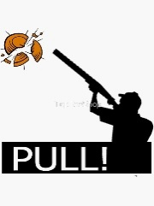
TRAP NEWS: Trap Practice: Happening every Tuesday from 5:00–8:00 PM, we’d be grateful to have you join us for an evening of trap shooting fun! If no one shows up by 6PM, Trap will be closed for the night🦃🍁Shells are available for $9.00/box, and it’s only $11.00/50 birds for members and guests, with junior’s round just $6 🦃💵. The gate will be open for our practice session, so bring family and friends who might want a taste of trap shooting fun! 👨‍👩‍👧‍👦🎯 🔫. 🧑‍🏫🍂

No shotgun? No problem! The Club and some generous members will have a few to borrow for the night. You’ll just need to purchase ammo and cover the practice fee for the birds Also, learn to clean a shotgun!💥📦.
Butler County Traveling Trap League (BCTL) is comprised of 4 Clubs: Mars, Evans City, RC Men’s Club and Butler City. It meets on Wednesday nights and the next one at Mars is June 3, 2026. We rotate to a different Club each week. Registration/Shooting starts at 4:00 PM.
We will need help marking, loading the houses and in the kitchen and get activity hours for your time. Talk to Scott Cukovich if you have any questions about the League and Mark Sabina (724-679-0204) for questions about needs for the kitchen.
North Suburban Traveling Trap League (NSTL) comprises North Side, Rosedale, Mars and Millvale Gun Clubs and is held on Mondays. The next shoot at Mars is Monday, June 1, 2026. at 4:00 to 8 PM. League price is $14.00/50 birds
If you are interested in shooting either League, let Scott C know. If you are interested in marking (scoring), loading the Trap houses with birds and cleaning up let Scott C. know or just show up to see what it is all about. We have papers in the office to help one learn what to do. Activity hours are signed for the hours you are present. If anyone has any questions, call Scott at 724-679-9596. We also have the Kitchen open for a meal each League night at Mars. Anyone interested in making entrees, salads or desserts, helping to serve and/or clean up let Mark @ 724-679-0204 know. Meals will be a $6.00 donation. If anyone has any questions, call Mark .
Butler County Youth Field Day – Saturday June 6th, 2026, all day. Field Days introduce participants to outdoor sports such as archery, trapping, and hunting through closely supervised hands-on activities. An adult must accompany all youth participants and can accompany more than one youth. Please ensure that your child meets the age requirements of the specific event that you are registering for as each event is different. Need to register for the event at https://www.pa.gov/agencies/pgc. Registration was open and closed in 3 hrs. this yr. Look on the PGC website for others in area (Beaver County info posted at Club).
Grounds Work 🍂 🛠️ Reach out to Joe Weltner at 412-292-2622 if you can’t make it to a work day for a list of things that need completed around the Club that can be done during the week or at your leisure.
Spring Clean-Up Help Needed for inside!
With Spring events and rentals in full swing, we need help keeping the Club clean and welcoming. Please contact Faye at 724-321-2691 (text or email) to schedule a time you can help.
🎯🎯🎯 SPRING SALE 🌼Looking for the perfect spring pickup—or a light, comfortable upgrade for yourself? Club merchandise is on sale now with Bob! Perfect for breezy days, meetings, and everyday wear. Stop by meetings or League nights to shop:
Caps ($15) Short sleeves ($10) Long sleeves ($15) Zip & pullover hoodies ($15). Great prices, great gear—don’t miss out on these fresh spring deals! 🌷


The Club’s Marketplace

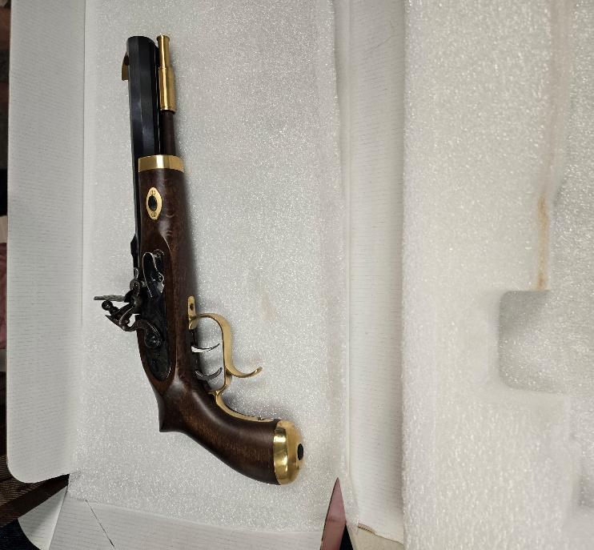
- Don Davidson is selling a muzzleloader pistol, Traditions Trapper Model #P-1090. (Reference/resource – Gun Broker value $477.00 to $548.00)
Asking $400.00

2. Call Mark Sabina at 724-321-2691 if interested in a
2007 Yamaha 650 V-Star Motorcycle Less than 5000 miles on it. Garage kept.
Not inspected. Great starter bike or work-on bike. $1000 or best offer.

